# How to setup Vue.js with TypeScript in ASP.NET Core

## Introduction

This sample demonstrates how to setup Vue.js with TypeScript in ASP.NET Core

## Sample prerequisites

* Visual Studio 2017 or above. [Visual Studio Home Page]
* Visual Studio enabled ASP.NET Core develop component.
* Node.js 6.0 and Npm 3.0 or above.
* Vue-cli has installed.

**npm install –g vue-cli**

## Building the sample

* Input **%solution folder%/VueSource/** in command line.
* Input **npm install** , to install dependency package.
* Input **npm run build**, to build the vue project, and then you can find the compilation file in **%solution folder%/VueSource/dist**.
* Copy all the files to **wwwroot** folder in ASP.NET MVC project.
* Copy the content in **index.html** to **Views/Home/index.cshtml**.
* Open the solution file “**CSVueJsWithTypeScriptInASPNETCore.sln**” use Visual Studio.
* Press **F6 Key** to build the ASP.NET Mvc project.

## Running the sample

* Use Visual Studio to open the sample solution **CSVueJsWithTypeScriptInASPNETCore.sln**, then press **F5 Key** or select Debugging from the menu.
* When the project is running, you will see below page in browser.

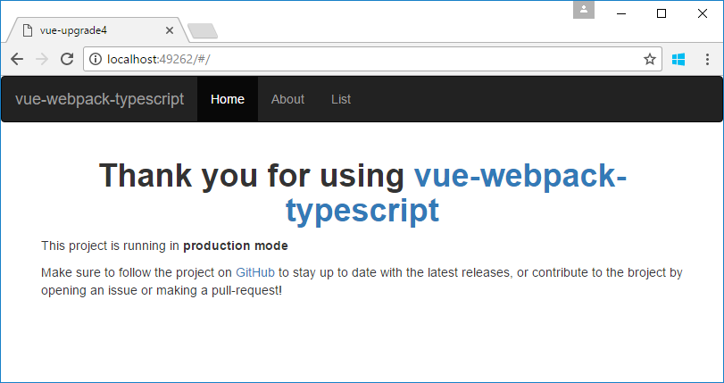

## For setup a new project

* First, install the vue-cli.

Input **npm install –g vue-cli** in command line.

* Initialize the vue project by template vue-webpack-typescript.
  + Create a folder and enter the folder by command line.
  + Input **vue init ducksoupdev/vue-webpack-typescript VueSource.**
  + Input the project name, project description etc.
  + Enter the project folder by command line.
  + Input **npm install** to install dependency packages.

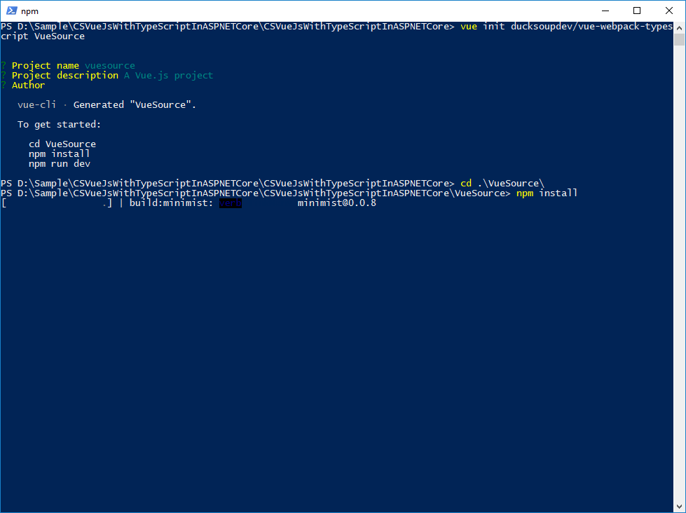

* And then, Input **npm run build** to build the vue project.

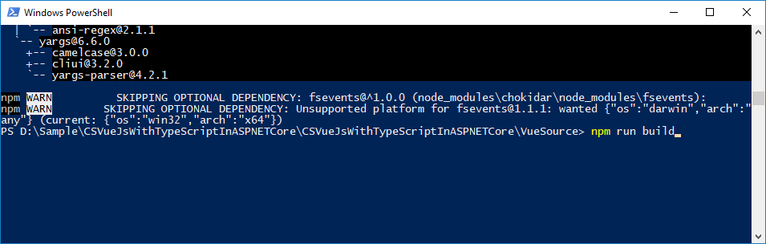

* When building has finished, you can find the compilation file in **%solution folder%/VueSource/dist**.

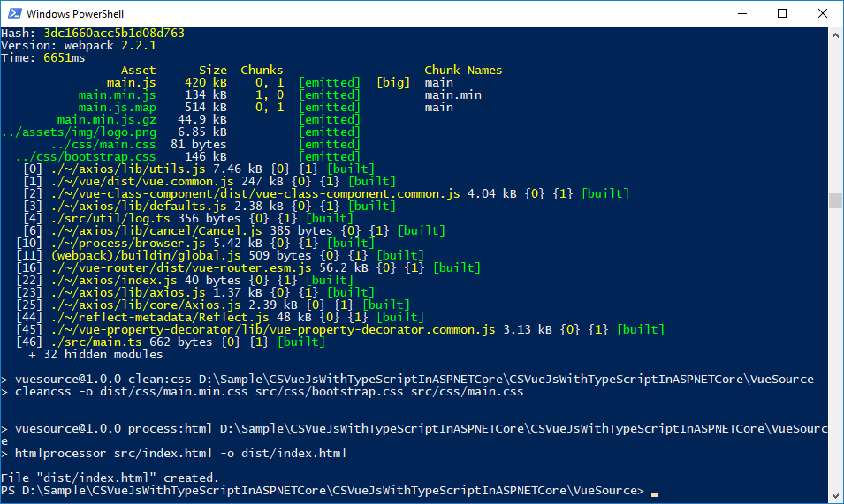

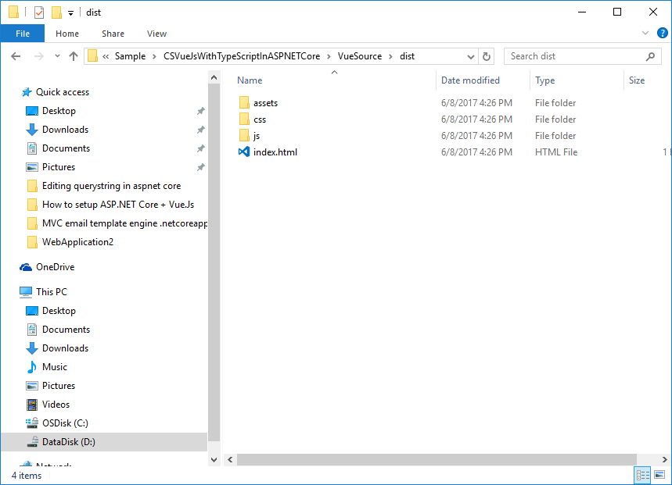

* Create a new empty ASP.NET Core project, and copy all the files in dict folder and paste to the wwwroot folder in ASP.NET Core project.

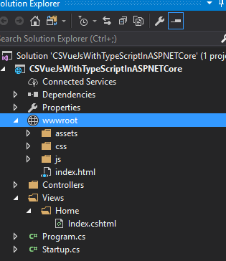

* Add the static files support and mvc.

public class Startup

{

public void ConfigureServices(IServiceCollection services)

{

services.AddMvc();

}

public void Configure(IApplicationBuilder app, IHostingEnvironment env, ILoggerFactory loggerFactory)

{

loggerFactory.AddConsole();

if (env.IsDevelopment())

{

app.UseDeveloperExceptionPage();

}

app.UseStaticFiles();

app.UseMvcWithDefaultRoute();

}

}

* Create Controller and views.

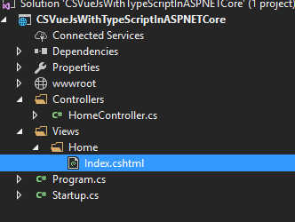

* Copy content from **wwwroot/index.html** to **Views/Home/Index.cshtml**
* Press **F5 Key** to run project.

## More information

<https://vuejs.org/>

<https://github.com/vuejs/vue-cli>

<https://github.com/ducksoupdev/vue-webpack-typescript>